2.59: (a) Denote the time for the acceleration (4.0 s) as t₁ and the time spent running at constant speed (5.1 s) as t₂. The constant speed is then at₁, where a is the unknown acceleration. The total l is then given in terms of a, t₁ and t₂ by

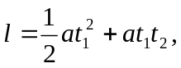

and solving for a gives

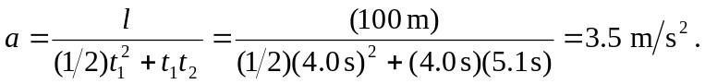

(b) During the 5.1 s interval, the runner is not accelerating, so a = 0.

(c)

(d) The runner was moving at constant velocity for the last 5.1 s.

